**AWS S3 SERVICE**

Step 1 : Open S3 service console in aws website

Step 2 : Create a bucket

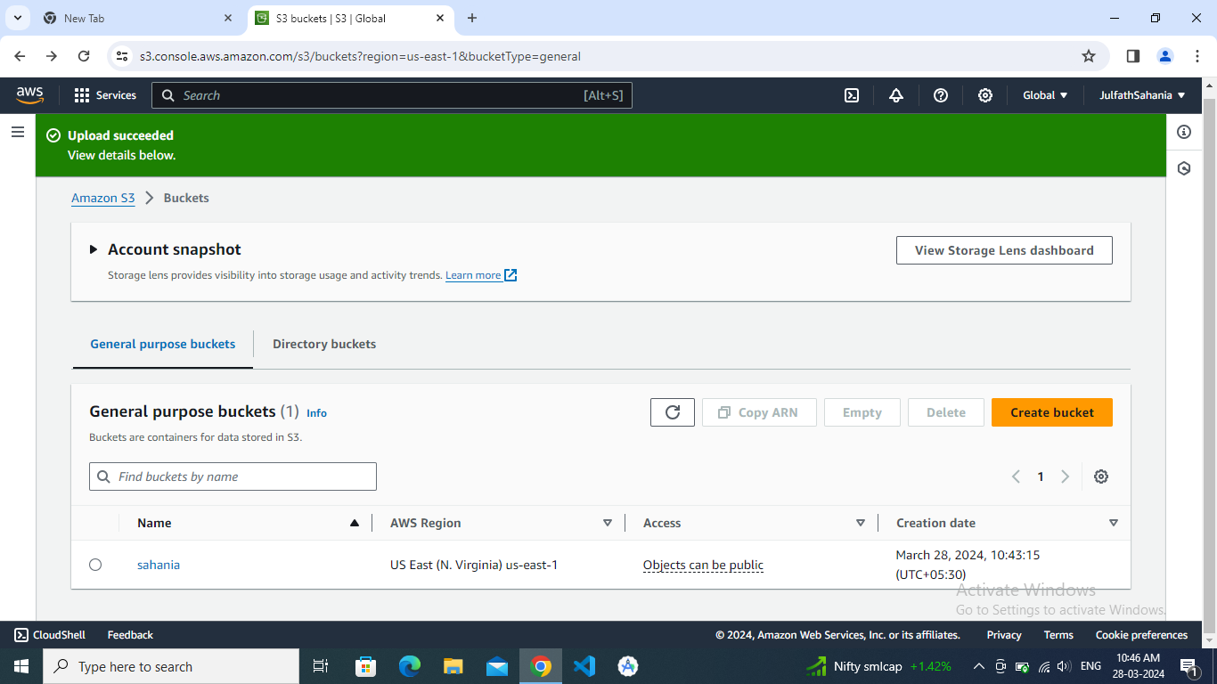

Step 3 : Give the bucket name customize the settings.

Step 4 : Upload the files

Step 5 : Get the succeed status

